**TURTLE RACE**

**S. E. Computer Engineering**

By

**Nithin Menezes 59**

**Lance Lopes 49**

**Selas Moro 68**

Supervisor:

Under the guidance of

**Ms. Priya Chaudhary**



**TABLE OF CONTENTS**https://docs.google.com/drawings/u/0/d/sZEAI6nV83dBzkx2GinV31g/image?w=34&h=25&rev=1&ac=1&parent=1wNZQS8ivHw6ePNnM-3AfkEQrohe_Ehmm

|  |  |  |
| --- | --- | --- |
| **Sr. No.** | **Contents** | **PageNo.** |
| **1** | **AIM** | **3** |
| **2** | **DESCRIPTION** | **3** |
| **3** | **DOMAIN** | **5** |
| **4** | **REQUIREMENTS** | **6** |
| **5** | **PSEUDO CODE** | **7** |
| **6** | **TEST CASE** | **10** |
| **7** | **CONCLUSION** | **12** |
| **8** | **REFERENCE** | **12** |

**Aim:** Write a program in python to implement a turtle race game(a single player game)

**REPORT:**

**Description:** Use loops to draw a race track and create a racing turtle game.

What you will make?

This project introduces for loops through a fun turtle race game. Loops are used to draw the race track and to make the turtles move a random number of steps each turn. If you have a group of people to play the game, each person pick a turtle and the one that gets the furthest is the winner.

First we will import turtle ,where the point is there on the turtle. All properties are imported in the turtle. “Random import randint” is used because we require random integer. When “time sleep” is used the turtle will stop for require time.

Now penup and pendown function was used:

Penup is used to make a line whereas pendown will not make a line.

For example:

pendown()

right(90) :This moves the object to the right of 90 degree.

Pendown(0,0) :It will not make a line,but will place it to the origin.

“for step in range” is used to make track.

Forward and backward is used for directions.

Given part in the program:

For example:

t1=Turtle()

t1.color('coral')

t1.shape('turtle') //The turtle will start moving as directed//

t1.penup()

t1.goto(0,-15)

t1.pendown()

.

For the track:

for x in range(6):

right(90)

penup()

forward(30) //it will start making the five horizontal lines//

left(90)

backward(320)

pendown()

forward(320)

for x in range(18):

pendown()

backward(5)

penup() //it will start making the vertical lines//

backward(5)

penup()

left(90)

forward(20)

speed(0)

**RULES OF THE GAME**:

**1.Start of the game**

The players decide or challenge their friends by predicting their winning turtle.

**2.Speed of the Turtle**

The speed of the turtle is taken randomly by the program.

**3.End of the game**

The turtle with the fastest among them wins the race (1st,2nd and 3rd position) followed by the player that predicted their turtle.

**DOMAIN**

**GUI**

A graphical user interface (GUI) is an interface through which a user interacts with electronic devices such as computers, hand-held devices and other appliances. This interface uses icons, menus and other visual indicator (graphics) representations to display information and related user controls, unlike text-based interfaces, where data and commands are in text. GUIl representations are manipulated by a pointing device such as a mouse, trackball, stylus, or a finger on a touch screen.

The need for GUI became apparent because the first human/computer text interface was through keyboard text creation by what is called a prompt (or DOS prompt). Commands were typed on a keyboard at the DOS prompt to initiate responses from a computer. The use of these commands and the need for exact spelling created a cumbersome and inefficient interface.

* **Python GUI –** This project uses Python 3. We recommend using [Trinket](https://trinket.io/), which allows you to write Python code online.
* Trinket lets you run and write code in any browser, on any device.
* Trinkets work instantly, with no need to log in, download plugins, or install software.
* Easily share or embed the code with your changes when you're done.

## **Create Your Free Account**

Let's get started! Your free account will let you create trinkets, see interaction statistics for each trinket you create, and more.

## **Free Interactive Resources**

Trinket will present the following free resources in collaboration with open source authors and our non-profit partners.

**Requirement of the project:**

* Python IDLE version 3.6 or 3.7

**ALGORITHM**

**Code**

import turtle

from turtle import *

from random import randint

import time

time.sleep(2)

#write(10)

pendown()

forward(320)

right(90)

penup()

forward(180)

pendown()

right(90)

forward(20)

right(90)

forward(180)

backward(180)

left(90)

forward(300)

right(90)

forward(180)

right(90)

for step in range(16):

#write(step)

right(90)

penup()

forward(180)

for x in range(18):

pendown()

backward(5)

penup()

backward(5)

penup()

left(90)

forward(20)

speed(0)

for x in range(6):

right(90)

penup()

forward(30)

left(90)

backward(320)

pendown()

forward(320)

t1=Turtle()

t1.color('coral')

t1.shape('turtle')

t1.penup()

t1.goto(0,-15)

t1.pendown()

t2=Turtle()

t2.color('blue')

t2.shape('turtle')

t2.penup()

t2.goto(0,-45)

t2.pendown()

t3=Turtle()

t3.color('red')

t3.shape('turtle')

t3.penup()

t3.goto(0,-75)

t3.pendown()

t4=Turtle()

t4.color('yellow')

t4.shape('turtle')

t4.penup()

t4.goto(0,-105)

t4.pendown()

t5=Turtle()

t5.color('green')

t5.shape('turtle')

t5.penup()

t5.goto(0,-135)

t5.pendown()

t6=Turtle()

t6.color('purple')

t6.shape('turtle')

t6.penup()

t6.goto(0,-165)

t6.pendown()

time.sleep(2)

for turn in range (100):

t1.forward(randint(1,5))

t2.forward(randint(1,5))

t3.forward(randint(1,5))

t4.forward(randint(1,5))

t5.forward(randint(1,5))

t6.forward(randint(1,5))

**TEST CASES**

**1.Start of the game**

The players decide or challenge their friends by predicting their winning turtle.

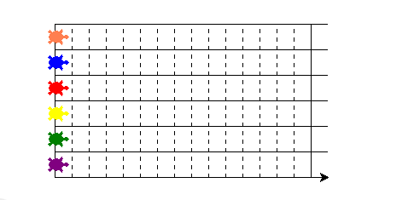

**2.Speed of the Turtle**

The speed of the turtle is taken randomly by the program.

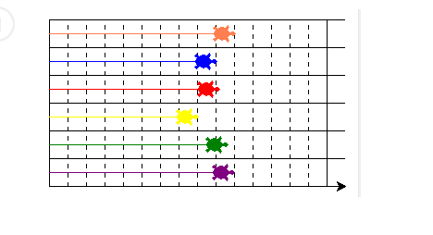

**3.End of the game**

The turtle with the fastest among them wins the race (1st,2nd and 3rd position) followed by the player that predicted their turtle.

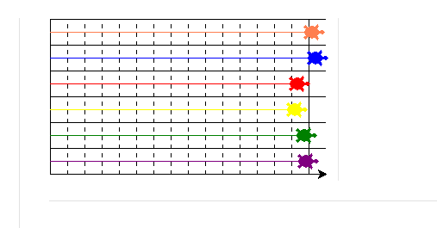

**CONCLUSION**:

Sucessfully implemented the program for Turtle race using single player and got the desired output.

By making this turtle race game we learnt how to:

* Write loops in Python
* Use random numbers in Python
* Draw lines in different colours with Python Turtle

**REFRENCES :**

* <https://projects.raspberrypi.org/en/projects/turtle-race>
* <https://www.youtube.com/watch?v=3MEhpfqzOPs>
* Wikipedia